# **Dashboard**

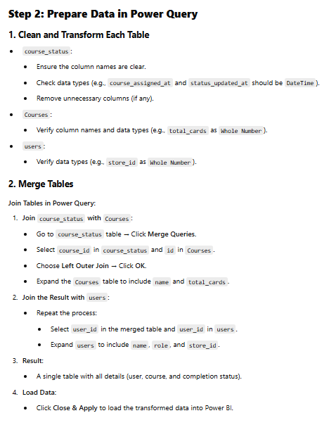

**1] No changes in DataTypes,**  
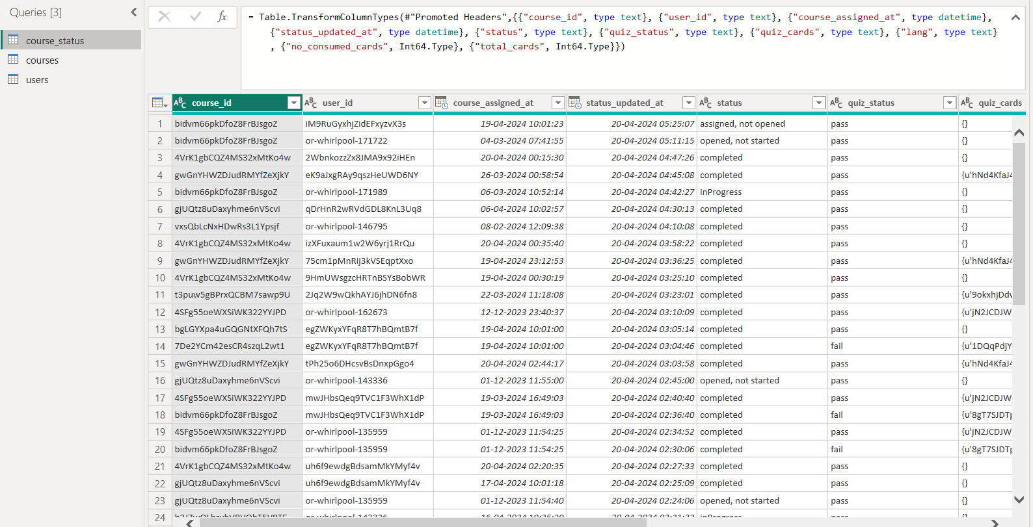

**2] Merge Tables:**

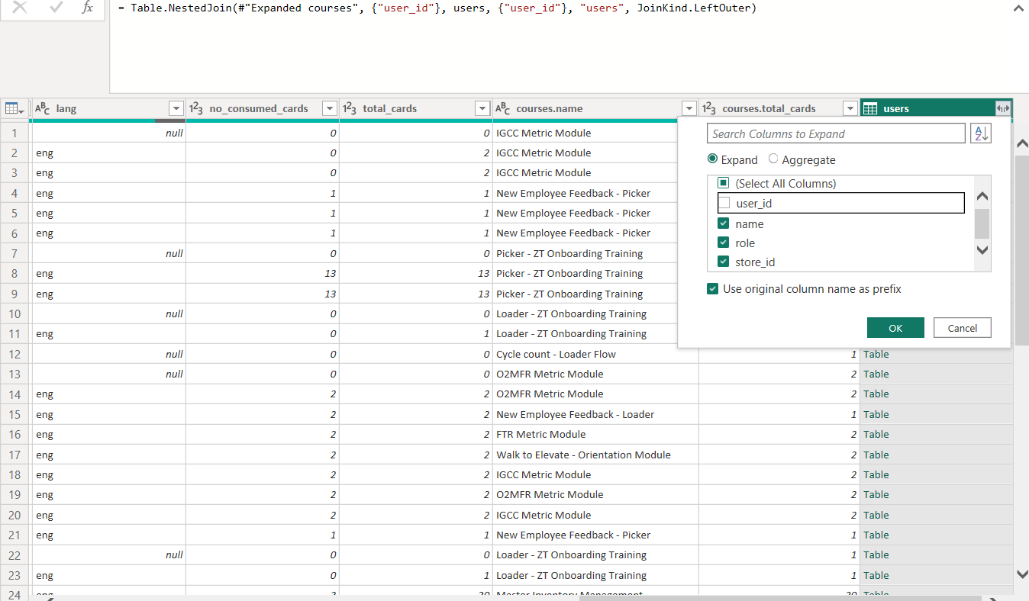

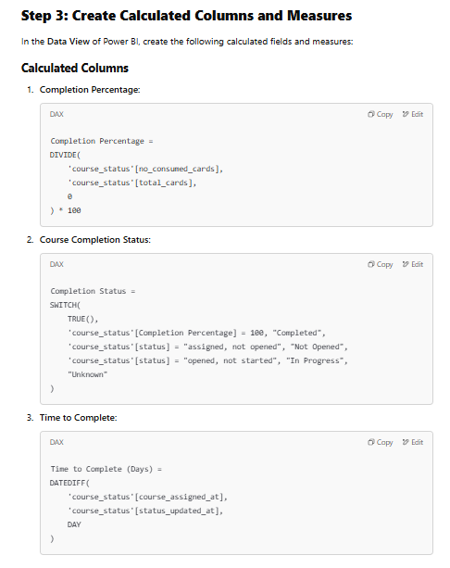

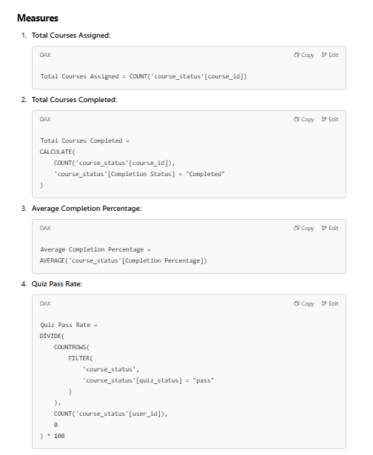

## **1] Nudge managers of locations which have staff with poor completion % to ensure everyone complete the courses**

Yes, the table visualization with the specified columns and filters is correct for the given requirement. Here's why:

* **Columns:**
  + **store_id**: Identifies the manager's location.
  + **Average_Completion_Percentage:** Highlights the average course completion percentage for each store.
* **Filter:**
  + **Completion_Category** contains 'Poor': Focuses on locations where staff have a poor completion percentage (i.e., < 50%).
* **DAX Measures:**
  + **Average_Completion_Percentage**: This measure correctly calculates the average completion percentage across all records. The use of COALESCE ensures no null values disrupt the visualization.
  + **Completion_Category**: The categorization logic is correct, as it assigns "Poor" for averages below 50%, "Medium" for 50%-74%, and "Good" for 75% and above.

**2. Explaining This Visualization in an Interview**

If asked about this visualization in an interview, here's how you can explain it step by step:

**Objective of the Visualization**

* The goal is to identify and nudge managers of locations where the staff has a poor completion percentage (< 50%) to improve their course completion rates.

**How It Works**

1. **Columns:**
   * The store_id column identifies each location.
   * The Average_Completion_Percentage column shows how well staff at each location are completing their assigned courses.
2. **Filter:**
   * The table is filtered to only show stores where the average completion percentage falls under the "Poor" category (< 50%).
3. **DAX Measures:**
   * Average_Completion_Percentage: Calculates the average completion percentage for all staff at a given store, ensuring accuracy even if some values are missing (COALESCE handles nulls).
   * Completion_Category: Categorizes stores into "Poor," "Medium," or "Good" based on their average completion percentage, enabling easy filtering.

**Why This Visualization Is Valuable**

* It helps management focus on problematic stores that require immediate attention.
* By targeting locations with "Poor" performance, the company can take corrective actions, such as engaging with managers to motivate or train staff.

**Future Enhancements**

* Add more dimensions, such as:
  + Number of Employees: To understand whether larger teams correlate with lower percentages.
  + Course Difficulty: To see if certain courses are harder for specific stores.
* Include trends over time to track whether nudging managers improves completion rates.

**Key Points to Highlight**

* The visualization is **focused**, showing only relevant data (poor-performing stores).
* **Actionable Insights**: Directly nudging managers can lead to measurable improvements.
* **Scalability**: The DAX measures and filters are adaptable for additional categories or metrics.

## **2] Evaluate skill levels of the staff based on the scores achieved and adjust the course material / test difficulty accordingly**

**Objective of the Visualization**

* The goal is to evaluate the skill levels of staff based on their quiz pass rates and identify areas where course material or test difficulty may need adjustment.

**How It Works**

1. **X-Axis (users.role):**
   * Breaks down the analysis by roles (e.g., Manager, Salesperson, etc.), showing skill levels across different staff categories.
2. **Y-Axis (quiz_pass_rate):**
   * Represents the percentage of quizzes passed, which serves as an indicator of skill level for each role.
3. **Legend (users.role):**
   * Differentiates roles visually, making the chart more interpretable.
4. **Filter (users.role is not blank):**
   * Ensures the data only includes meaningful roles and excludes irrelevant records with blank roles.

**Why This Visualization is Valuable**

* **Insightful Comparisons:** Helps identify roles with lower skill levels based on quiz performance.
* **Actionable Outcomes:**
  + For roles with low pass rates, course material can be simplified or tailored to their needs.
  + For roles with consistently high pass rates, quiz difficulty can be adjusted to maintain a challenge.
* **Focus on Role-Based Insights:** Allows targeted interventions for specific roles, maximizing training effectiveness.

## **3] Evaluate at which point the course becomes hard or boring and is distracting users - so that the course content can be adjusted accordingly**

**Objective of the Visualization**

* The goal is to evaluate at which point a course becomes hard or boring and identify the need for content adjustment.

**How It Works**

1. **X-Axis (courses.name):**
   * Displays the course names, allowing for analysis on a course-by-course basis.
2. **Primary Y-Axis (Total_Courses_Completed, Total_Courses_InProg, Total_Courses_Opened_notStarted):**
   * Provides a breakdown of user engagement:
     + Total_Courses_Completed: Indicates successful engagement.
     + Total_Courses_InProg: Highlights courses where users are stuck or progressing slowly.
     + Total_Courses_Opened_notStarted: Suggests lack of initial interest or engagement.
3. **Secondary Y-Axis (Avg of time_to_complete_in_days):**
   * Measures how long users are taking to complete or progress through the course. A high average completion time indicates potential issues with content complexity or distractions.

**Why This Visualization is Valuable**

* **Identifies Problematic Courses:**
  + Courses with high Total_Courses_InProg and high Avg_Time_To_Complete_In_Days likely indicate content that is too difficult or confusing.
  + Courses with high Total_Courses_Opened_notStarted may need more engaging introductions.
* **Actionable Adjustments:**
  + Simplify content, improve clarity, or break up challenging sections for problematic courses.

**Possible Insights and Actions**

1. **High Total_Courses_InProg + High Avg_Time_To_Complete_In_Days:**
   * Content may be too hard or confusing; consider simplifying explanations or breaking the material into smaller parts.
2. **High Total_Courses_Opened_notStarted:**
   * Lack of initial engagement. Improve the course's introduction to grab attention.
3. **Low Total_Courses_Completed:**
   * Indicates users are struggling to finish. Analyze why users drop off and adjust accordingly.

**3. Key Points to Highlight During the Interview**

1. **Alignment with Objectives:**
   * This visualization answers the key question by combining engagement metrics with time-to-complete insights.
2. **Actionable Insights:**
   * Directly pinpoints where course content needs adjustment.
3. **Scalability:**
   * Easily adaptable for filtering by other attributes (e.g., users.role, store_id) or analyzing trends over time.

1] How can you identify managers of stores with poor staff course completion rates to ensure they take action to improve course completion percentages?

**Manager-Level Details for Poor Completion%:**   
I created a table visual to filtered the stores with avg_completion_percentage < 50% to identify poor-performing locations. Enabled drill-through on the store_id column so that clicking on it in the table dynamically displays the corresponding manager_name in the another table visual, helping to nudge managers effectively.

2] How do you determine which courses are perceived as difficult, independent of user roles, to make necessary adjustments to the course material?

**Difficult Courses Identification**

I created a column chart with course_name on the x-axis and course_completion_percentage on the y-axis. Used tooltips to display course_difficulty, calculated using a SWITCH formula, to classify courses as "Easy," "Moderate," or "Tough." This visualization highlights tough courses, allowing adjustments to their content.

3] How do you evaluate the specific points within a course where it becomes challenging or boring, using quiz card details, to improve user engagement and course content?

**Course Boredom/Difficulty Insights**  
I analyzed quiz data by converting quiz_cards into a valid JSON format and parsing the details into separate columns.

* Created a column chart for CorrectAnswerPercentage (y-axis) against course_name and quizcard_id (x-axis) to identify challenging sections in course.
* Built another chart for HighAttemptsPercentage to identify confusing cards with multiple attempts.
* Finally, I analyzed time_to_complete_in_days based on course_assigned_at and status_updated_at columns to detect boring courses and initial engagement trends based on the courses which are opened and not started.